Data Flow Diagrams:

Project Design Phase-II

Data Flow Diagram & User Stories

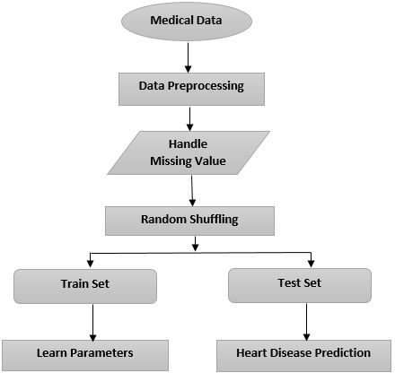

User Stories

Use the below template to list all the user stories for the product.

|  |  |  |  |  |  |  |
| --- | --- | --- | --- | --- | --- | --- |
| **User Type** | **Functional Requirement (Epic)** | **User Story Number** | **User Story / Task** | **Acceptance criteria** | **Priority** | **Release** |
| Customer (Mobile user) | Registration | USN-1 | As a user, I can register for the application by  entering my email, password, and confirming my password. | I can access my account  / dashboard | High | Sprint-1 |
|  |  | USN-2 | As a user, I will receive confirmation email once I have registered for the application | I can receive confirmation email & click confirm | High | Sprint-1 |
|  |  | USN-3 | As a user, I can register for the application through Facebook | I can register & access the dashboard with Facebook Login | Low | Sprint-2 |
|  |  | USN-4 | As a user, I can register for the application through Gmail | I can register & access the dashboard with  Gmail Login | Medium | Sprint-1 |
|  | Login | USN-5 | As a user, I can log into the application by entering email & password | I can register & access the dashboard with Gmail Login | High | Sprint-1 |
|  | Dashboard | USN-6 | Profile - view & update your profile | I can see the profile. | High | Sprint-1 |
|  |  | USN-7 | Change Password - user can change the password | I can able to change the password. | High | Sprint-1 |
|  |  | USN-8 | Home - Analyze your Heart | I can detect the health  condition from where ever I want. | High | Sprint-1 |
|  |  | USN-9 | The user will have to fill in the below 13 fields for the system to predict a disease -Age in Year -Gender -Chest Pain Type -Fasting Blood Sugar -Resting Electrographic Results(Restecg) -Exercise Induced | These are the categories available in that application. | High | Sprint-2 |

|  |  |  |  |  |  |  |
| --- | --- | --- | --- | --- | --- | --- |
| **User Type** | **Functional Requirement (Epic)** | **User Story Number** | **User Story / Task** | **Acceptance criteria** | **Priority** | **Release** |
|  |  |  | Angina(Exang) -The slope of the peak exercise ST segment -CA – Number of major vessels colored by fluoroscopy -Thal -Trest Blood Pressure -Serum Cholesterol - Maximum heart rate achieved (Thalach) -ST  depression induced by exercise(Oldpeak) |  |  |  |
|  |  | USN-10 | View Doctors - view doctor detail by searching by names or filter by specialty | Using this application, people can known that the speciality doctors. | Medium | Sprint-1 |
| Customer (Web user) | System Requirement | USN-11 | 1. Hardware Requirement    1. Laptop or PC  * I5 processor system or higher * 4 GB RAM or higher * 128 GB ROM or higher ii. Android Phone (12.0 and above) | These are all the specification available in your PC. | High | Sprint-2 |
|  |  | USN-12 | II. Software Requirement  iii. Laptop or PC   * Windows 10 or higher * Android Studio | Install your application. This system can be used to predict the presence of heart disease. | Medium | Sprint-2 |
|  |  | USN-13 | Reference- https://ieeexplore.ieee.org/document/9619208/ | Go and Check our Reference link. | Medium | Sprint-1 |
| Customer Care Executive | Dashboard | USN-14 | Query | You can post your queries in the text box  available in that application. | High | Sprint-1 |
|  |  | USN-15 | Toll Free | Ask your doubts in given number(8365492107). | High | Sprint-1 |

|  |  |  |  |  |  |  |
| --- | --- | --- | --- | --- | --- | --- |
| **User Type** | **Functional Requirement (Epic)** | **User Story Number** | **User Story / Task** | **Acceptance criteria** | **Priority** | **Release** |
|  |  | USN-16 | Ratings | Give your ratings as your wish. | Medium | Sprint-1 |
| Administrator | Dashboard | USN-17 | Verification | Verification through CAPTCHA  Verification through I’m not a robot | High | Sprint-1 |
|  |  | USN-18 | validation | Reconfirming the new password Sending a two digit number in (Google account) your Old devices, so that you can enter into a new device By entering the two digit number. | High | Sprint-2 |
|  |  | USN-19 | Feedback - send feedback to the Admin | Please send your feedback to host. | Medium | Sprint-2 |